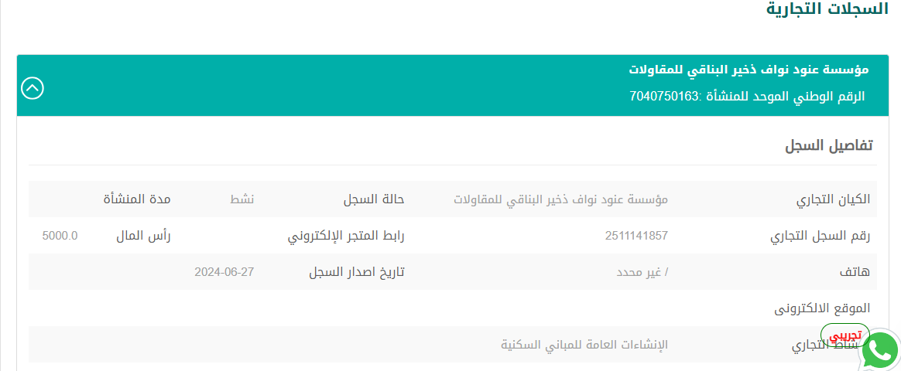
MUHAMMAD KAMRAN  SAFETY OFFICER  Experienced Safety Officer with a strong background in ensuring workplace safety and compliance across various industries in Riyadh, KSA, and the UAE. Skilled in risk assessment, safety training, incident investigation, and implementing safety protocols to reduce hazards. Proven track record of maintaining regulatory compliance, fostering a safety-first culture, and mitigating risks to protect employees and assets. Dedicated to promoting a safe and healthy work environment through continuous improvement and effective communication. | RIYADH-KSA  Iqama: Transferable/Freelance  Willing To relocate  Cell : +966 59 3821079  Driving License: KSA  mkamrank89@gmail.com
EXPERIENCE Khaleej Eng. Works RIYADH KSA  HSE OFFICER 2024-----2025  - Safety Program Development: Designed and enforced safety programs, ensuring OSHA and industry compliance.  - Risk Assessment: Conducted audits and assessments to identify and mitigate hazards.  - Safety Training: Delivered training on protocols, equipment use, and emergency procedures.  - Accident Investigation: Investigated incidents, prepared reports, and recommended actions.  - Compliance Monitoring: Ensured adherence to safety regulations and policies.  - PPE Management: Oversaw proper use of PPE and employee training.  - Emergency Preparedness: Developed response plans and coordinated drills.  - Documentation: Maintained records of inspections, incidents, and compliance.  - Regulatory Liaison: Coordinate with regulatory bodies for safety inspections.  - Continuous Improvement: Analyzed incidents to improve safety protocols.  - Equipment Inspections: Ensured equipment met safety standards.  - Safety Culture Promotion: Engaged employees to foster a safety-first culture.  - Drill Coordination: Organized emergency drills to ensure readiness.  - Incident Reporting: Managed and reviewed incident reports for improvements.  KKPOWER INT— SAFETY SUPERVISOR 2021-2023  Senior Safety Officer  - Develop, implement, and maintain safety policies and programs in compliance with local, state, and federal regulations  - Regularly review and update safety procedure to ensure effectiveness.  - Conduct regular safety inspections, audits, and risk assessments to identify hazards in the workplace.  - Analyze trends in accidents and near-misses to develop preventative measures.  - Lead or coordinate safety training programs for employees on various safety topics, including emergency response, hazard communication, personal protective equipment (PPE), etc.  - Ensure that all safety equipment (e.g., fire extinguishers, first-aid kits, PPE) is in good working condition.  My water Pvt Ltd Safety Officer 2019-2021  AL BAWADI OIL REFINERY Safety Officer 2015-2018  - Enforce compliance with all HSE policies, procedures, and regulations.  - Conduct regular site inspections, audits, and risk assessments to identify potential hazards.  - Develop and implement safety training programs for employees and contractors.  - Investigate incidents, near misses, and accidents, and prepare detailed reports with corrective actions.  - Maintain and update safety records, permits, and documentation.  - Ensure that Personal Protective Equipment (PPE) is used properly and is in good condition.  - Liaise with local authorities, emergency services, and regulatory bodies as required.  - Promote a proactive safety culture through toolbox talks, safety meetings, and hazard awareness sessions.  - Participate in the development and review of Job Safety Analyses (JSA), Permit to Work (PTW) systems, and emergency response plans.  - Monitor the handling, storage, and disposal of hazardous materials.  JUMA AL MAJID GROUP DUBAI/ABUDHABI Safety Officer 2013 - 2016  PROJECTS  Forklift & Aerial Work Platform Operations in Jungheinrich (Aerial Working platform) . Managed safety for forklift and aerial platform operations, including inspections, operator training, incident investigations, and compliance with OSHA and site-specific safety standards. Risk Assessment and Hazard Identification (HAZID):  - Façade & UPVC Façade Installation Projects overview:  Ensured HSE compliance during UPVC and external façade installation, including lifting operations, work-at-height safety, and contractor coordination on high-rise projects.  - Furnace base Oil Project Overview (United Arab Emirates-Sharjah)  Worked on the installation, commissioning, and operation phase of a furnace centrifuge system used in oil and gas processing operations. The project involved high-temperature systems, rotating machinery, hazardous materials, and confined space entry. Developed and implemented a site-specific safety plan for off shore drilling, conducted safety briefings, led risk assessments, ensured PPE compliance, and managed incident investigations to reduce hazards and improve safety.  EDUCATION  NEBOSH-IGC UK 2018-2019  MS PROJECT MANAGEMENT 2022-2024  SZABIST UNIVERSITY  MBA-ITM 2004-2007  INTERNATIONAL ISLAMIC UNIVERSITY  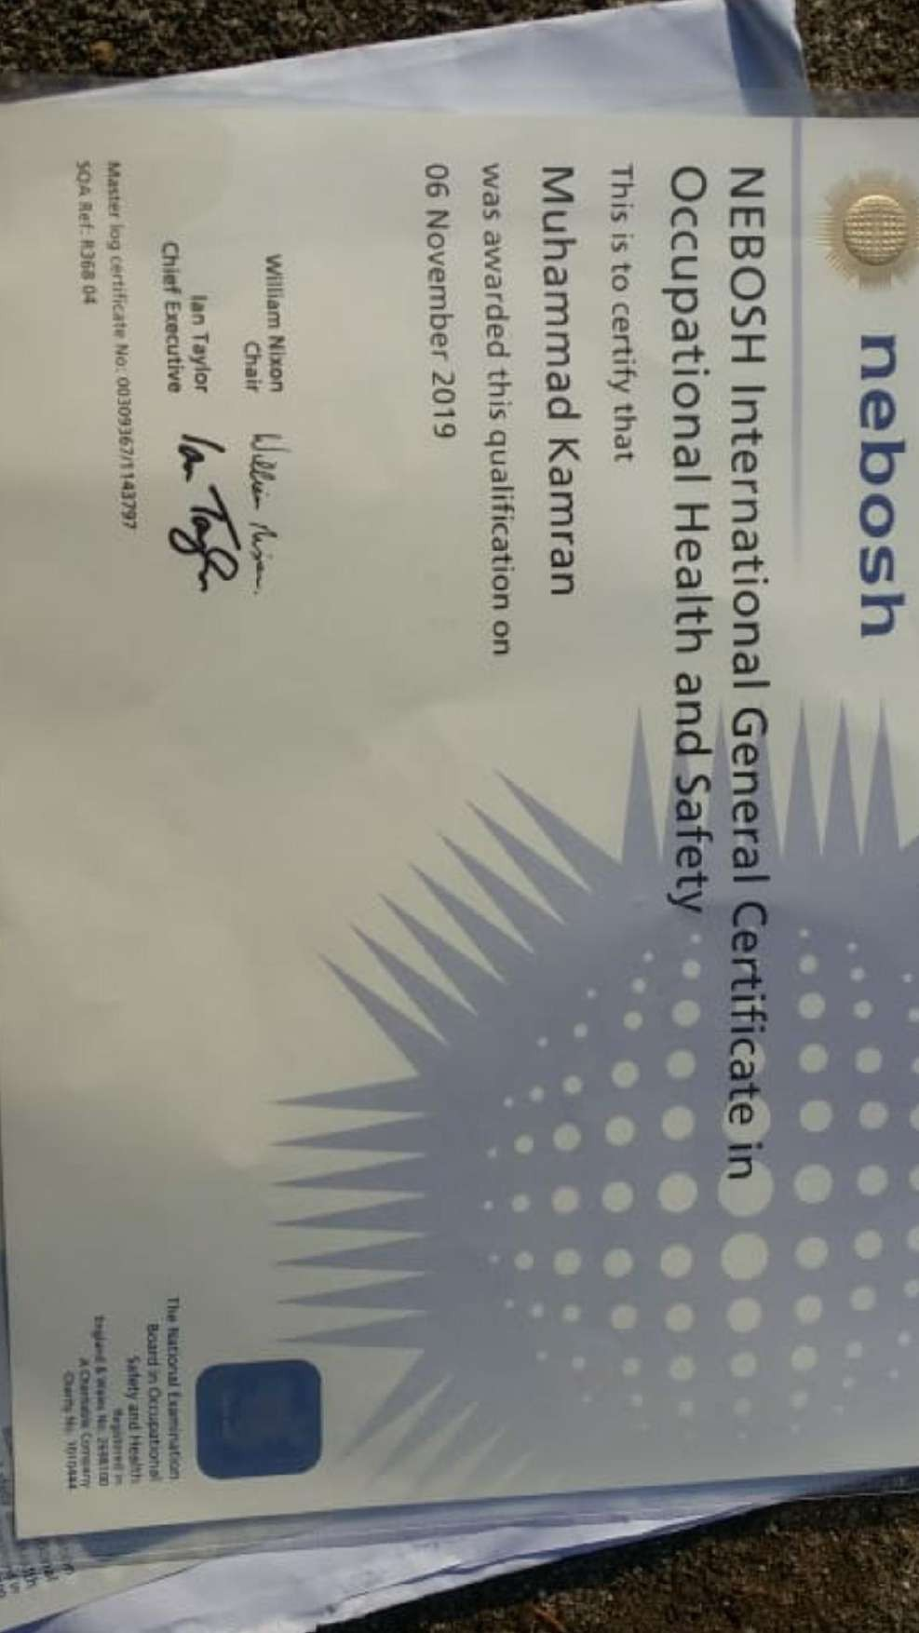 | Technical Safety Skills  Hazard identification  Risk Analysis  Accident/Incident Investigation  Safety audit & inspection  Emergency response planning  Safety program implementation  PPE Mgt  Fire safety & Prevention  Soft Skills  Communication Skills  Problem solving skills  Training & Mentoring  Conflict resolution  Adaptability  Decision making  SOFTWARE PROFICIENCY  MS OFFICE SUIT  Google Work Space:Google Docs,Sheets,Gmail  CRM:ZOHO Bigin CRM PROJECT MGT TOOLS:MS PROJECT  ASANA,TRELLO JIRA  Driving License : KSA  LANGUAGES  ENGLISH  URDU  Arabic-Beginner
